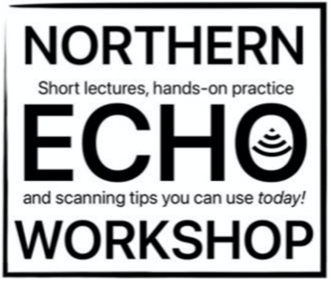

REGISTRATION FORM

Name / Specialty / Seniority:
Date of workshop registered:
Mobile:
Email:
Dietary preference
& allergy:

Please tell us your learning needs so we can help you get the most out of the course

Cost: $300.00 including lunch and tea break.

Please forward your registration form to NHAR.Remittance@nh.org.au and peter.cheng@nh.org.au. Program and materials will be forwarded once payment is received and your place is confirmed.

Payment details:
Bank Account Name: Northern Health
BSB 083170
Account 123170261
Reference NNHY3224

